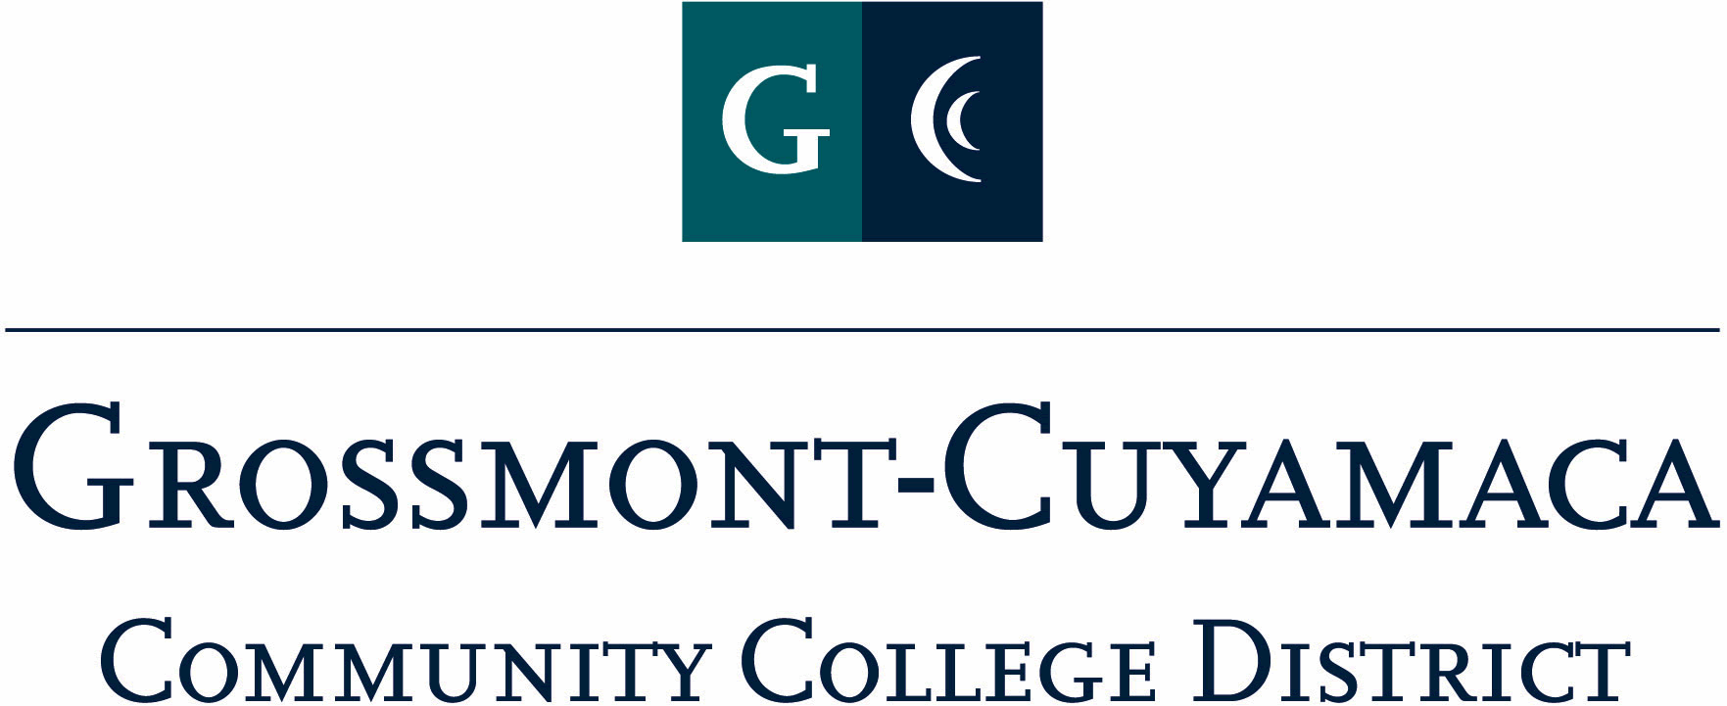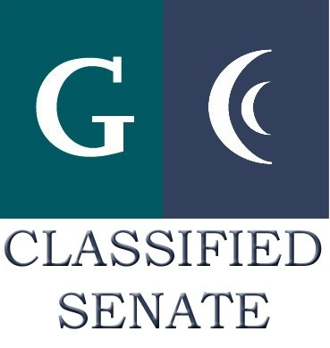
D R A F T
CLASSIFIED SENATE
EXECUTIVE BOARD MEETING
December 3, 2009 – Meeting Minutes

Members Present: Debi Miller, Tasa Campos, Avelina Wilder, Monica Farris, Wendy Corbin, Yvette Macy, Maria Briney, Angela Johnson, Jacqueline Osborne, Pat Murray, Karen Ostegard, Karen McCoy
Members Absent: Maggie Gonzales, Patricia Bailey, Scott Howell, Jean Wallace
Members Excused: Paula Tillery, Kimberly Gioscia

1. Welcome and Call to Order

The meeting was called to order at12:05p.

2. Approval of Minutes from November 3, 2009

The minutes from November 3, 2009 meeting were approved. M/S/A Corbin/Murray.

3. Communication

VP Reports

District: Wendy Corbin reported no updates from her area.

Grossmont: Pat Murray reported that Grossmont College is about to finalize its 6 year strategic plan for 2010-2016. She was invited to take a photo with the president and academic senate president to show teamwork on the document. As soon as I am in possession of the document, I will pass it to you all.

She attended the Leadership Council and some of the topics discussed included, EAP a new assessment tool, H1N1 POD, and forms exercise. Our Health Science Lab will be the holding place for more than 10,000 vaccines which may arrive over the holiday break.

She has met with faculty development leaders and they are working on a joint invitation to classified staff for flex-week workshops.

She also met with Patty Morrison to talk about updating our staff technology center for teaching and learning opportunities. We plan to write a proposal to fund the updating of software and computers.

She added that she had purchased $33.33 for the Tecate children donation. The purchase included new items: a pair of pants, 2 shirts, S1 Spongebob game, 1 hot wheel, slinky and 2 toy books. She is splitting the cost of 2 new pair of shoes at $30 with Pat Bailey. She will deliver to the ACE office on Thursday. She also included a blanket.

For the EOPS/CARE Holiday party she purchased a $50 Souplantation gift certificate and gave it to Pearl Lopez to raffle at the event.

Cuyamaca: Tabled.

President’s Report: D. Miller reported that her and Maggie Gonzales, VP at Cuyamaca College were invited by the Chancellor to attend the CLASS workshop. It was very interesting and the data was a lot to digest, but very telling.

D. Miller informed the group that Laura Murphey had resigned her position as Senator at Grossmont College. If the E-Board knew of anyone that was interested in being a Senator from this college, she could appoint.

D. Miller also explained the recent decision of the Governing Board to now have November 11th as the actually day off for staff for veterans’ day. The calendar should be approved at the next Board meeting.

D. Miller reminded the group of the holiday card signing on December 12 from 9a-11a. The holiday cards have been printed and are ready for signature. J. Osborne will be supplying the labels.

Treasurer Report: In Paula Tillery’s absence the President referenced the current trust available funds to the group. Starting Balance: $2,332.09; Income: $715.15; Expenses (including open PO): $2,600.30; Available Funds: $446.94. The available funds calculation and IFAS figures differ by +64.85. We are hoping this corrects itself in time for the next report.

4. Continuing Business:

Meet & Greet – D. Miller informed the group that there were approximately 12 E-Board members attending the event.

Assist-A-Student – A. Johnson reported that she had spoken to student services about this classified senate sponsored event, and that pins would be available for those interested in volunteering.

Padre Survey E-mail Draft: Avelina Wilder reported that she will have a draft for review for the February meeting.

5. Fundraising Activities:

Tecate Children – J. Osborne stated that all gifts are due to ACE by 12/3. If at all possible, place gifts into a large box and then wrap that box. Don’t forget to put the code on the gift.

See’s Candy – Y. Macy reported that this fundraiser closes on Friday, and she will be sending estimated profit worksheet to the Board by next week.

Dudley Bread – Y. Macy indicated that the Treasurer report figures were accurate. Dudley’s produce a $264.85 profit.

Cookbook – M. Briney reported that the committee will be getting together this Friday. They will be working on a timeline for notification.

6. Committee: Pat Murray reported that she had spoken to Scott Howell and the C&Bs have been updated as far as the quorum definition and Board member voting change. She would like to add Appendices to the document to include: CCSA Handbook, Internal Process, etc.

7. New Business:

Classified PDW Workshop – D. Miller reported that there will be workshop offered to all district classified during this week. This is the same presentation that was done at Grossmont College during Fall PDW. It will just be adapted to include Cuyamaca College particulars. This workshop will be presented by CSEA President, Jan Recktenwald, CS President, Debi Miller, and Interim President Ron Manzoni.

Foster Youth Donation – D. Miller informed the group of a recent request for donation that came in from Cuyamaca College to support the foster youth holiday party. The group is interested in donating, but feel that since the senate covers the entire district that Grossmont should be included in the donation as well. After discussion with the group, D. Miller will talk to Grossmont and see if they have the same request and then forward the information to the E-Board for approval.

Mother Goose Parade – Wendy Corbin would like to see if the Classified Senate could be involved with the Mother Goose parade. It would help highlight both colleges to the community. Since planning for this event is on a short time line, the President suggested putting this on the E-Board Annual Organizational Meeting agenda for discussion.

The meeting adjourned at 12:59p.

